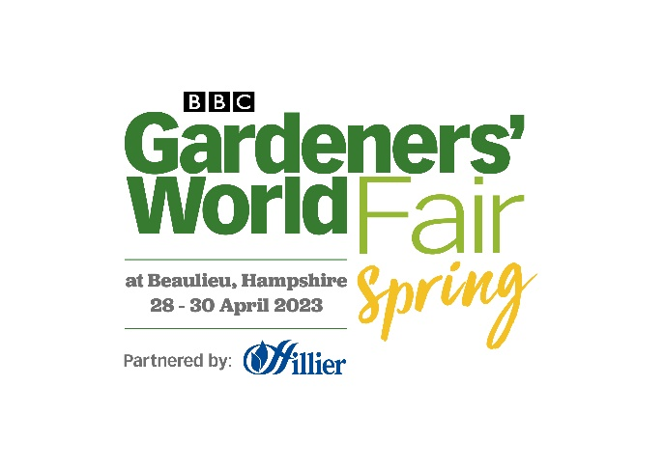

Media news

February 15th 2023

**BBC Gardeners’ World Spring Fair returns to Beaulieu in April with spectacular Hillier Secret Garden**

Friday 28th – Sunday 30th April

**Exciting new highlights are being announced for the return of the** [**BBC Gardeners’ World Spring Fair**](https://www.beaulieu.co.uk/events/bbc-gardeners-world-fair-spring/) **to Beaulieu, from 28th to 30th April 2023. With tickets are on sale now, whether you’re a keen gardener, experienced plant enthusiast or a budding beginner, inspiration will be in plentiful supply.**

**Headline partner, Hillier**, will present a stunning walk-through garden inspired by The Secret Garden. Enclosed by high hedges, visitors will step inside to discover a spectacular display of colour co-ordinated plants and shrubs portraying the movement of the sun during a spring day, from the cool whites and purples of daybreak to the fiery reds and oranges of sunset.

As the UK’s biggest tree grower, trees will feature prominently in the Hillier garden with a contemporary area planted with brilliant white trunked Himalayan Birch (Betula ‘Jacquemontii’) amongst a sea of lush green hostas. Wildflowers will surround the entire garden. Visitors feeling inspired to recreate elements of the Hillier garden at home will find plant information throughout the display, advice stations and a large Hillier retail area offering plants and garden accessories. Hillier Gardening Club members will be able to access the alfresco Club Lounge at the Spring Fair.

The shopping doesn’t stop there. New nurseries and plant specialists Alchemy Ferns, Calamazag, Eleplants, Hedgehog Plants, John Cullen and Jurassic Plants will be joining the line-up of **more than 150 exhibitors** offering quality outdoor and indoor plants, garden tools, kit and accessories. Don’t want to carry your haul of new plants and garden bargains around the show? The Spring Fair’s **Shop ‘n’ Drop** is the place to leave shopping so you can enjoy your day bag-free, collecting it all when you head home.

Visitors to the Spring Fair will find **imaginative design and planting ideas** at every turn. Award-winning designer Paul Stone’s showcase garden, *Theatre of Greens*, will be packed with veg and edible plants and features an accompanying programme of daily talks. Hosted by Chris Bavin, the talks area will feature ‘grow your own’ gurus including Garden Organic’s Head of Horticulture and former Blue Peter gardener, Chris Collins, fungi experts The Caley Brothers, veterans from the National Vegetable Society and more to be announced. New Forest based garden design firm, The Landscape Service, will present the calming Nordic Retreat, a large Showcase Garden featuring spaces to relax, unwind and rejuvenate. An array of compact 9m2 Beautiful Borders will offer inspiration for small gardens and challenging spaces with the theme of ‘My Garden Escape’, and on a micro scale, organic gardening charity, Garden Organic, will present a 1m x 1m design inspired by bugs, birds and biodiversity, featuring a veg plot, composting system and high-rise bug hotel.

Horticultural students from Kingston Maurward, Merrist Wood and Cannington Campus (Bridgewater and Taunton College) will create budget-friendly gardens, under the expert eye of mentor Cherry Carmen, the award-winning garden designer whose accolades include a Gold Award at BBC Gardeners’ World Live.

Spring Fair visitors can book added extras for their day out, like the ever-popular **Plant Expert Tours** of Beaulieu’s Victorian walled gardens with **Lucy Chamberlain, Saul Walker** and **Beaulieu Head Gardener, Kelvin Yapp**; Floral Crown workshops with tutors from the National Association of Flower Arrangement Societies’ (NAFAS) Hampshire group; and Oyster Mushroom Growing workshops with the Caley Brothers.

The **BBC Gardeners’ World Magazine Stage** features special guests, **Frances Tophill** (Friday), **Arit Anderson** (Saturday) and **Adam Frost** (Sunday), who will be joining the Magazine’s editors to share practical advice about ‘what to do now’ in your garden.

For visitors looking for a bite to eat, there will be delicious food and drink to be enjoyed at the **BBC Good Food Market** and a variety of artisan producers and street food vendors, with live music at the **Bandstand**.

**Rachel Poletti-Gadd, Portfolio Director - Gardening Division at Immediate Live, organisers of BBC Gardeners’ World events, said:** “This will be our third Spring Fair and we can’t wait to be back at beautiful Beaulieu, surrounded by gorgeous plants. Whether you’ve got a bare patch of grass, a mature garden or a window box, our inspiring events for hands-on gardeners are packed with advice, inspiration and take-home ideas, plus you’ll find some well-known faces sharing their experience, expertise and probably a visitor selfie or two! Of course, a good day out isn’t complete without something tasty to eat and drink so a visit to the BBC Good Food Market and street food vendors is a must. With so much to offer gardening fans and first-time gardeners alike, including all of Beaulieu’s wonderful attractions, this really is the perfect spring day out.”

Visitors to the Spring Fair can enjoy a full day out as tickets include access to Beaulieu’s stunning grounds, gardens and attractions, including Palace House, the National Motor Museum, the Monorail, and Little Beaulieu adventure play area.

**Rachael Goldstraw, Head of Marketing & Business Development at Beaulieu Enterprises, said:** “We always look forward to the BBC Gardeners’ World Spring Fair and to sharing our own wonderful gardens with green-fingered fans from far and wide. Spring is the perfect time of year to make garden plans for the warmer months and we can’t wait to see what the incredible designers, landscapers, growers and exhibitors involved will be inspiring us with.”

Tickets for the BBC Gardeners’ World Spring Fair at Beaulieu are on sale now. Advance tickets from £15, concessions £14, children £8.50, under 5s free. Find out more and buy your tickets at [www.beaulieu.co.uk/events/bbc-gardeners-world-fair-spring](https://www.beaulieu.co.uk/events/bbc-gardeners-world-fair-spring/).

– ENDS –

**Notes to editors:**

**For further information, interviews or pictures, please contact:**

Julie Parmenter at Brampton PR, e: [jparmenter@hotmail.co.uk](mailto:jparmenter@hotmail.co.uk), tel: 07775 715936 / 01981 251820

Press accreditation is open. To apply for a pass and for more information on the show, [please click here](https://www.bbcgardenersworldlive.com/spring-fair/spring-fair-press/)

About the **BBC Gardeners’ World Spring Fair,** Beaulieu, Hampshire**:**

Friday 28 April 9.30am – 5pm

Saturday 29 April 9.30am – 5pm

Sunday 30 April 9.30am – 5pm

Book tickets at **bbcgardenersworldfair.com**.

Details correct at time of print.

BBC Gardeners’ World events are organised and presented by Immediate Live (the trading name of River Street Events Ltd). The Gardeners’ World logo is a trademark of BBC. © BBC. Licensed by BBC Studios.

With thanks to suppliers:

** 

Hedges Direct and Rolawn are garden product suppliers, with Hedges Direct providing quality hedging and Rolawn supplying their turf and topsoil.

**Further information from:**

Sarah Sandys-Renton Julie Parmenter

Immediate Live Event Contact Brampton PR

E: [ssr@immediate.co.uk](mailto:ssr@immediate.co.uk) E: [jparmenter@hotmail.co.uk](mailto:jparmenter@hotmail.co.uk)

T: 07500 762168 T: 07775 715936 / 01981 251820

Ben Coleman

Beaulieu Marketing Executive

E: [ben.coleman@beaulieu.co.uk](mailto:ben.coleman@beaulieu.co.uk)

T: 01590 614641