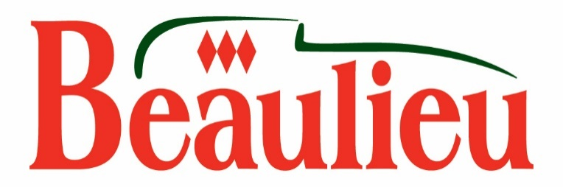

A fairy tale Victorian Christmas at Beaulieu
December 17th – January 2nd

A magical fairy tale Victorian Christmas at Beaulieu will include a life-size gingerbread house in the courtyard at Palace House, storytelling, games and carol singing around the grand piano from December 17th – January 2nd.

Visit the gingerbread house in a snow-dusted glade for a unique photo opportunity, which is perfect for the family Christmas card, and smell spices wafting from the cook baking gingerbread men in the Victorian kitchen.

Be enchanted by storytelling with Christmas fairy tales and follow the fairy tale-themed quiz trail around Palace House and the rest of the attraction. You may also be lucky enough to spot the ‘Mouse in the House’ before claiming your quiz trail reward.

Then be transported back in time to a Victorian Christmas, with carol singing around the grand piano in the Lower Drawing Room. Enjoy the charm of traditional decorations with presents under the tree and Victorian toys including a rocking horse and push-along bear at Palace House, which has been home to the Montagu family since 1538. Drink a glass of hot fruit punch in front of the roaring log fire and see the impressive dining hall table, which will be dressed ready for Christmas day.

Then head out into the grounds of the attraction to see one of the largest outdoor Christmas trees in the New Forest by the National Motor Museum, which is home to more than 250 vehicles from throughout motoring history.

Be inspired by Christmas presents, from motoring memorabilia to children’s toys in the Visitor Reception Gift Shop. While the Kitchen Shop at Palace House offers traditional gifts, from tasty preserves to silverware and country house gifts.
All of the Christmas activities are included in your general admission entrance. For Beaulieu ticket prices or more information see www.beaulieu.co.uk/events/victorian-christmas/ or call 01590 612345. Beaulieu is open every day except Christmas day from 10am-5pm.
A great-value Beaulieu ticket includes entry to all of the Beaulieu attractions including the National Motor Museum, the World of Top Gear, Palace House, the 13th century Beaulieu Abbey and grounds. Take a ride on the high-level Monorail or hop on the Veteran London Bus to see the Beaulieu sights.
--ENDS--

Further information from:

Jane Riddiford
Public Relations Manager
Tel: 01590 614603
E: pr@beaulieu.co.uk
To register on the Beaulieu Press Centre please visit www.beaulieu.co.uk/press

